St. Mark Church
235 East Fourth Street Emporium, Pennsylvania 15834

Rev. Paul S. Siebert, Pastor

Pastoral Vision: We at St. Mark/St. James glorify Jesus Christ as we . . .

PURSUE full and active participation rather than presume regular faith practice of our members.
REACT to the changing conditions of the local Catholic community,
STRIVE first and foremost for spiritual renewal in every committee, organization and activity;
BUILD belonging for the various age groups, personalities, genders, and states of life;
INVITE the occasional and nominal back to their spiritual home;
SERVE the needs of the greater community.

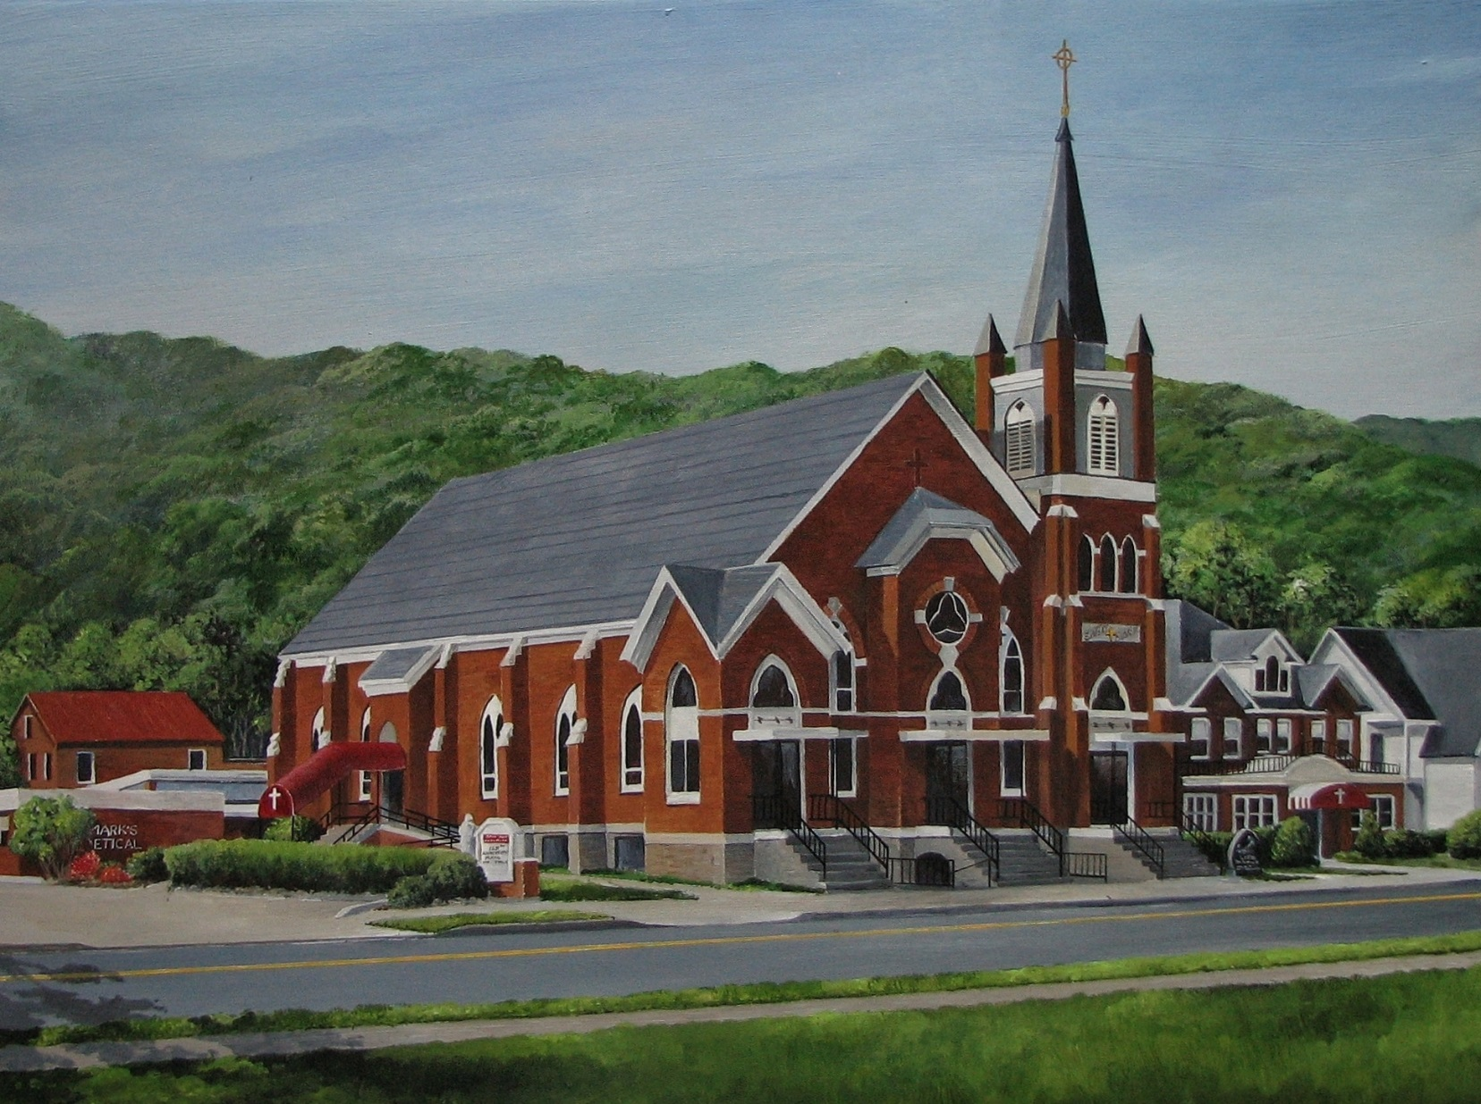
MASS INTENTIONS
MONDAY, MARCH 19
8:10 a.m. BUTCH CATON (ANNIV.)
(The Family)
(2 Sm 7:4-5a, 12-14a, 16/Rom 4:13, 16-18; Lk 2:41-51a)
TUESDAY, MARCH 20
8:10 a.m. COMMUNION SERVICE
(Nm 21:4-9; Jn 8:21-30)
WEDNESDAY, MARCH 21
8:10 a.m. SARAH DeLUCIA (MONTH’S MIND)
(Peter DeLucia)
(Dn 3:14-20, 91-92, 95; Jn 8:31-42)
THURSDAY, MARCH 22
8:10 a.m. PAULINE MOSCATO (MONTH’S MIND)
(Margie Tauses)
(Gn 17:3-9; Jn 8:51-59)
FRIDAY, MARCH 23
8:10 a.m. STEPHEN PERKINS (ANNIV.)
(The Family)
(Jer 20:10-13; Jn 10:31-42)
SATURDAY, MARCH 24
5:00 p.m. PEOPLES OF THE PARISHES
(The Pastor)
SUNDAY, MARCH 25
9:00 a.m. HARRY & BARB RAMSEY
(The FaMily)
(Mk 11:1-10; Is 50:4-7; Phil 2:6-11; Mk 14:1—15:47)

Sacrament of Reconciliation
Wednesday at 6:30 p.m.
Saturday Confessions at 2:30 p.m.
Anytime by appointment.
Baptisms
At all Sunday liturgies. Baptisms outside of Mass on the second Sunday of the month after
9:00 a.m. Mass.
Parents and Sponsors must attend Baptismal
Preparation Class.
Call the rectory for arrangements.
Sacrament of Matrimony
Please call the rectory for arrangements
six months prior to the wedding.
Prayer Requests
Margaret Burnside . . . . . . . . . . . . . 486-0344
Rectory Office Hours
Monday through Friday
9:00 a.m. to 3:00 p.m.
Mission Parish
St. James Church, Driftwood PA

Rectory . . . . . . . . . . . . . . . . . . . . . . . . . . . . . . 486-0569
Pastoral Minister . . Sister Frances Therese Matia, S.S.J.
Religious Education Facilitator . . . . . . Jennifer Abriatis
Pastoral Council President . . . . . . . . . . . Dan Martuccio
Finance Council Moderator . . . . . . . . . . . . . . . . Jay Edel
St. Mark Cemetery . . . . . . . . . . . . . . . . . . . . Don Fapore
Religious Education Center . . . . . . . . . . . . . . 486-0784
St. Mark Day Care Center . . . . . . . . . . . . . . . 486-2399

www.stmarkemporium.org

SIXTH SUNDAY OF EASTER MAY 21, 2017

MASS ATTENDANCE
MARCH 10-11, 2018
St. Mark: 5:00 PM – 111
9:00 AM – 160
OFFERTORY COLLECTIONS
MARCH 10-11, 2018
St. James: $643.00
St. Mark: $3,943.00

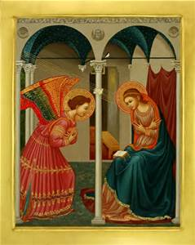
1:38 Women’s Conference
Fourth Annual Catholic Women’s conference in Erie will be held on Saturday, April 21st from
9:00 AM to 3:00 PM at
Our Lady of Peace Parish, Erie.
Cost is $40 per person, $35 for senior citizens or groups of 8, $25 for college students, $10 for high school students.
Call 814-455-7364 for more information or to register.
EXTRAORDINARY MINISTERS
WEEKEND OF MARCH 24-25 ~ PALM SUNDAY
5:00 PM – F. Pizzella, C. Schager, W. Smith, S. & L. Zoschg
9:00 AM– L Richnafsky, M. Singer, A. Slottje, R. Woods, P. Rodgers

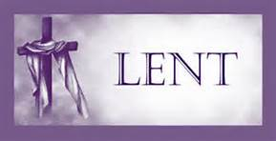
IN YOUR CHARITY,
Please pray for the souls of
ARLINGTON DUNKLE, father of Debbie Dunkle, who passed away recently.
May his soul and the souls of all the faithful departed rest in peace.
Amen
THE PONTIFICAL GOOD FRIDAY COLLECTION
Pope Frances has asked our parish to support the Pontifical Good Friday Collection, which helps Christians in the Holy Land.
Your support helps the church minister in parishes, provide Catholic schools and offer religious education. This collection also helps to preserve the sacred shrines. When you contribute to the Pontifical Good Friday Collection, you become an instrument of peace and join with Catholics around the world in solidarity with the Church in the Holy Land. Please be generous!

LECTORS:
WEEKEND of March 24-25 ~ PALM SUNDY
5:00 PM – Joe DeLucia & Jane Kamats
9:00 AM – John English & Ben Porkolab
ALTAR SERVERS:
5:00 PM – Nick Crisp, Noah & Zack Abriatis
9:00 AM – Melissa Stuart, Ryan Shaffer &
Sophia Fragale
CHILDRENS LITURGY:
Jen Abriatis

SCHEDULE OF EVENT
Sunday (18th) 10:00 AM – Last Lenten Adult Session ~ O’Connell Hall
NO Religious Ed. Classes…..
2:45 PM – Religious Ed. Students meet in Classroom to attend Penance Service
3:00 PM – PENANCE SERVICE
Wednesday (21st) 12:05 PM – LENTEN LUNCH ~ O’Connell Hall (Only $4.00)
3:30-5:00 PM – Religious Ed. Class Grades 1-5
4:30 PM – Stations of the Cross
5:00 PM – Adoration of Blessed Sacrament ~ Intention ~Peace in the World
6:00 PM – Confession
7:00 PM – Benediction
Thursday (22nd) 6:30 PM – Recitation of Rosary
Saturday (23rd) 2:30 PM – Confession
Sunday (24th) ~PALM SUNDAY~ Meet in O’Connell Hall to process into Church
10:15-11:30 – Religious Ed. Classes Grades 6-11

Welcome to St. Mark Church!
If you’re visiting Cameron County this weekend, welcome and thank you for celebrating the Eucharist with us! If you’re searching for a Spiritual home, we welcome you to join us in worship and invite you to become part or our church family. Please complete this form and return it to the parish office or drop it in the offertory basket.
Name __________________________________________________ Phone______________________________
Address___________________________________________________________________________________

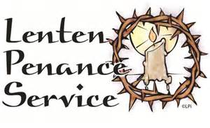
ST. MARK CHURCH EMPORIUM, PENNSYLVANIA

FIFTH SUNDAY of LENT

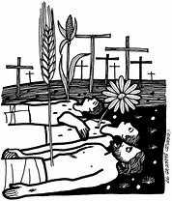
If we should like to see Jesus, we need to look for the fallen grains of wheat around us, the sick and impoverished, the abused and oppressed. If we should like to see Jesus, we need to look for those who are losing their lives, the victims of poverty, abuse, discrimination, and war.
What we need is a new covenant, a covenant of love and forgiveness. We need to have written in our hearts that we are God’s people that we aspire to be like Christ in transforming the darkness of the world’s pain into the life and joy of Easter.

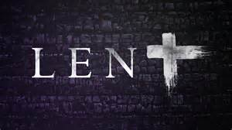
Our Community Lenten Service was such a nice occasion. It was a happy get-together. We all had a good time - - great singing, message and food to follow.
The few St. Mark people (13) kept saying “Where are St. Mark’s people?” We missed your presence. Please come with your family next time to be a good host.

SUNDAY EVENING COMMUNITY LENTEN SERVICES
The Community Lenten
Service will be TONIGHT, Sunday, March 18th @ 6:00 PM at the
Free Methodist Church (240 E. 4th St.)
Next Sunday, March 25th, PALM SUNDAY, services will be at
First United Methodist Church @ 6:00 PM.
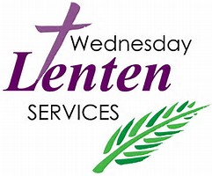
MAKE YOUR LENTEN DAY on
WEDNESDAY
MARCH 21, 2018
12:05 PM: Lenten Luncheon
Speaker: Rev. Lionel Owen
(Pastor @ Emporium Alliance Church)
4:30 PM: Stations of the Cross
5:00 PM: Exposition of Blessed Sacrament
ADORATION INTENTIONS OF BISHOP PERSICO:
‘Peace in the World’
6:00 PM: Confession
7:00 PM: Benediction

March 18, 2018 ~ Fifth Sunday of Lent Gospel: John (12:20-33) The coming of Jesus’ hour
Question of the week: Adult: Name a time you gave of yourself and you received a sense of satisfaction from it?
Youth: Tell us when you gave something away and you felt good about it?

ST. MARK PENANCE SERVICE
TODAY, SUNDAY,
MARCH 18th@ 3:00 PM
We’ll have four visiting priests. Please make plans to come to this wonderful opportunity.

Additional Local Parish Penance services:
Mon., Mar. 19th @ 6:30 PM: ST. LEO, RIDGWAY
Tues. Mar. 20th @ 7:00 PM: SACRED HEART,
ST. MARY’S
Thurs . Mar. 22nd, @ 6:30 PM: ST. BONIFACE in KERSEY
Palm Sunday, Mar. 25th @ 3:00 PM: ST. JOSEPH,
FORCE
Tues. of Holy Week, Mar. 27th @ 7:00 PM; ST. MARY’S, ST. MARY’S
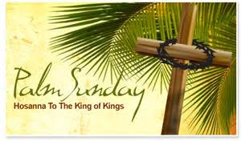

Next Sunday is
PALM SUNDAY
All those able to participate and join our procession without difficulty are asked to meet in O’Connell Hall for the beginning of services and procession into the church.

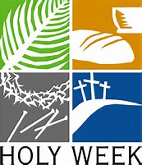
HOLY WEEK SCHEDULE
Please make plans to come to Holy Week Services, especially Easter Vigil.
Holy Thursday, March 29th @ 6:30 pm
Bring Bells, Consolidate your Rice Bowl change, bring non-perishable food items; Plan to spend time in silent Adoration sometime following services until 10:00PM.
Good Friday, March 30th @ 2:00 pm
Most solemn time to spend together commemorating the time Jesus died on the Cross for us.
Easter Vigil, March 31st @ 8:30 pm
Most important service!

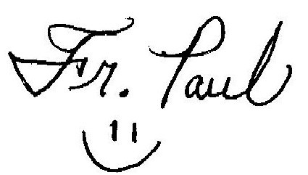
Thanks so much to Beth Malizia for co-coordinating the Care and Concern ministry during this recent term! It’s such a beautiful thing to serve those in need in our local area. We thank Beth for using her stewardship of time & talent. We welcome Brenda Sidun, who will now co-coordinate with Pat Rodgers, continuing the vital outreach ministry of the parish!

March 18, 2018 ~ Fifth Sunday of Lent Gospel: John (12:20-33) The coming of Jesus’ hour
Question of the week: Adult: Name a time you gave of yourself and you received a sense of satisfaction from it?
Youth: Tell us when you gave something away and you felt good about it?

