St. Mark Church
235 East Fourth Street Emporium, Pennsylvania 15834

Rev. Paul S. Siebert, Pastor

Pastoral Vision: We at St. Mark/St. James glorify Jesus Christ as we . . .

PURSUE full and active participation rather than presume regular faith practice of our members.
REACT to the changing conditions of the local Catholic community,
STRIVE first and foremost for spiritual renewal in every committee, organization and activity;
BUILD belonging for the various age groups, personalities, genders, and states of life;
INVITE the occasional and nominal back to their spiritual home;
SERVE the needs of the greater community.

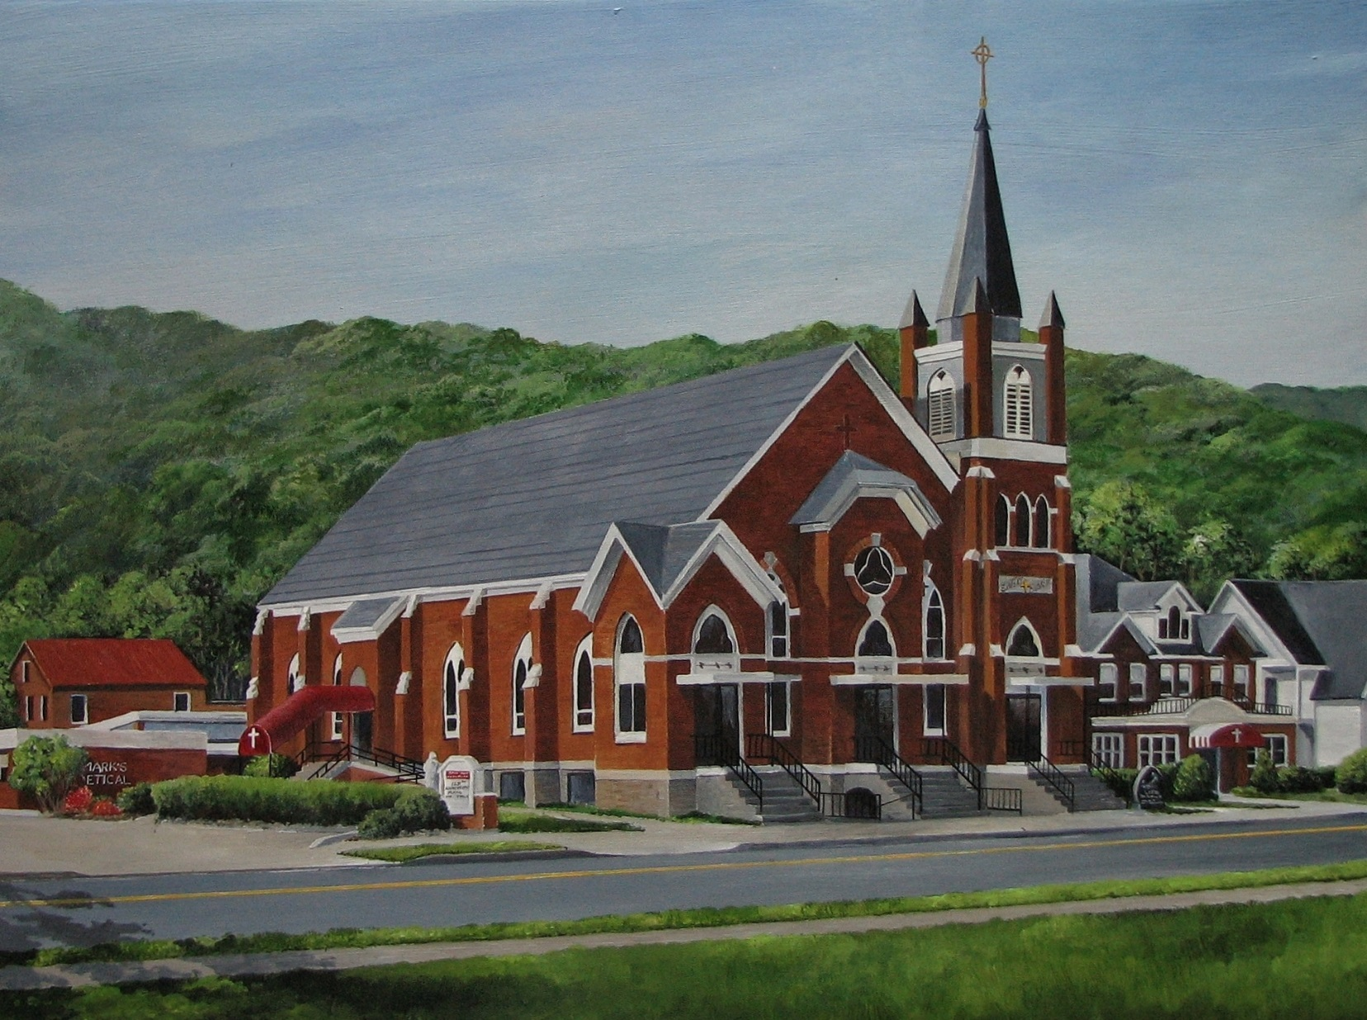
MASS INTENTIONS

MONDAY, MARCH 26
8:10 a.m. JUDY MONGILLO
(The Burfield Family Foundation)
(Is 42:1-7; Jn 121:1-11)

TUESDAY, MARCH 27
8:10 a.m. COMMUNION SERVICE
(Is 49:1-6; Jn 13:21-33, 36-38)

WEDNESDAY, MARCH 28
8:10 a.m. ARLINGTON DUNKLE
(Paul & Beth Malizia)
(Is 50:4-9a; Mt 26: 14-25)

THURSDAY, MARCH 29 HOLY THURSDAY
6:30 p.m. JANET TARTAGLIA
(Vicky Songer & Family)
(Ex 12:1-8, 11-14; 1 Cor 11:23-26; Jn 13:1-15)

FRIDAY, MARCH 30 GOOD FRIDAY
9:00 a.m. Morning Prayer
2:00 p.m. Celebration of the Lord’s Passion
(Is 52:13—53:12; Heb 4:14-16, 5:7-9; Jn 18:1—19:42)

SATURDAY, MARCH 31 EASTER VIGIL
9:00 a.m. Morning Prayer
8:30 p.m. PEOPLES OF THE PARISHES
(The Pastor)

SUNDAY, APRIL 1 EASTER SUNDAY
9:00 a.m. JEAN BAUER
(Margie Tauses)
(Acts 10:34a, 37-43; Col 3:1-4; Jn 20:1-9)

Sacrament of Reconciliation
Wednesday at 6:30 p.m.
Saturday Confessions at 2:30 p.m.
Anytime by appointment.
Baptisms
At all Sunday liturgies. Baptisms outside of Mass on the second Sunday of the month after
9:00 a.m. Mass.
Parents and Sponsors must attend Baptismal
Preparation Class.
Call the rectory for arrangements.
Sacrament of Matrimony
Please call the rectory for arrangements
six months prior to the wedding.
Prayer Requests
Margaret Burnside . . . . . . . . . . . . . 486-0344
Rectory Office Hours
Monday through Friday
9:00 a.m. to 3:00 p.m.
Mission Parish
St. James Church, Driftwood PA

Rectory . . . . . . . . . . . . . . . . . . . . . . . . . . . . . . 486-0569
Pastoral Minister . . Sister Frances Therese Matia, S.S.J.
Religious Education Facilitator . . . . . . Jennifer Abriatis
Pastoral Council President . . . . . . . . . . . Dan Martuccio
Finance Council Moderator . . . . . . . . . . . . . . . . Jay Edel
St. Mark Cemetery . . . . . . . . . . . . . . . . . . . . Don Fapore
Religious Education Center . . . . . . . . . . . . . . 486-0784
St. Mark Day Care Center . . . . . . . . . . . . . . . 486-2399
PALM SUNDAY _________ __ MARCH 25, 2018

MASS ATTENDANCE
MARCH 17-18, 2018
St. Mark: 5:00 PM – 118
9:00 AM – 142
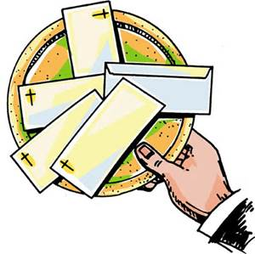
OFFERTORY COLLECTIONS
MARCH 17-18, 2018
St. James: $275.00
St. Mark: $2,706.00

EXTRAORDINARY MINISTERS: LECTORS:
Holy Thursday ~ 6:30 PM Holy Thursday ~ 6:30 PM
J. Abriatis, C. Dankesreiter, W. Smith, S. & L. Zoschg Vicky Songer & Pat Rodgers
Good Friday ~ 2:00 PM Good Friday ~ 2:00 PM
Ralph Grovanz & Melissa Stuart
Easter Vigil, Holy Saturday ~ 8:30 PM Easter Vigil, Holy Saturday ~ 8:30 PM
P. English, P. Housler, R. Moore, L. & D. Summerson Dave Malize, Theresa Blose & Sarah Abriatis

Easter Sunday ~ 9:00 AM Easter Sunday ~ 9:00 AM
L. Cooney, F. Pizzella, D. Dunkle, P. Rodgers, Volunteer Phil Burkhouse

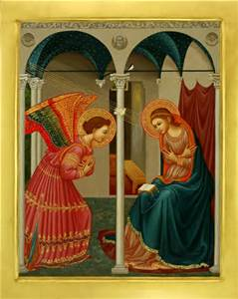
1:38 Women’s Conference
Fourth Annual Catholic Women’s conference in Erie will be held on Saturday, April 21st from
9:00 AM to 3:30 PM at
Our Lady of Peace Parish, Erie.
Cost is $40 per person, $35 for senior citizens or groups of 8, $25 for college students, $10 for high school students.
Call 814-455-7364 for more information or to register.

ALTAR SERVERS:
Holy Thursday ~ 6:30 PM Easter Vigil, Holy Saturday ~ 8:30 PM
Sarah Abriatis, Maggie Abriatis, Jonathan Good, Samantha Good, Jared
Noah & Zach Abriatis Whiting, Trisha & Terry Kossman
Good Friday ~ 2:00 PM Easter Sunday ~ 9:00 AM
Toni Dresser & Andy DeLucia Andy &Emily Richnafsky
SCHEDULE OF EVENT
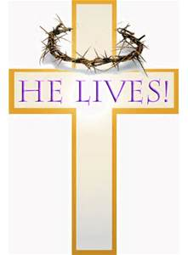
Sunday (25th) PALM SUNDAY
10:15-11:30 – Religious Ed. Classes Grades 6-11
Wednesday (28th) No Religious Ed. Class Grades 1-5
No Stations of the Cross
No Adoration of Blessed Sacrament
Confession by Appointment
Thursday (29th) 6:30 PM –HOLY THURSDAY SERVICE
Friday (30th) 9:00 AM– Morning Prayer
2:00 PM – CELEBRATION OF THE LORD’S PASSION
Saturday (31st) 9:00 AM – Morning Prayer
8:30 PM – EASTER VIGIL
Sunday (1st) 9:00 AM – EASTER SUNDAY MASS
No Religious Ed. Classes Grades 6-11

Welcome to St. Mark Church!
If you’re visiting Cameron County this weekend, welcome and thank you for celebrating the Eucharist with us! If you’re searching for a Spiritual home, we welcome you to join us in worship and invite you to become part or our church family. Please complete this form and return it to the parish office or drop it in the offertory basket.
Name __________________________________________________ Phone______________________________
Address___________________________________________________________________________________

ST. MARK CHURCH EMPORIUM, PENNSYLVANIA

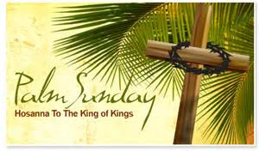
The Passion of Jesus
Today’s liturgy teaches us “to welcome our suffering,” to bear witness to God by following Christ’s example of suffering. We pray that the world “united with him in His suffering on the cross may share His
Resurrection and new life.”

SUNDAY EVENING COMMUNITY LENTEN SERVICE
The Community Lenten
Service will be TONIGHT, Sunday,
March 25th @ 6:00 PM at the
First United Methodist Church
PRAISE HIM IN MUSIC & SONG
Good Friday, March 30th, Services will be held at First Baptist Church @ 12:00PM

ST. MARK/ST. JAMES PARISH MISSION
You are invited to attend the
St. Mark/St. James Parish Mission the week of
April 22-25. It will run from Sunday until Wednesday night and be conducted by
Redemptorist Fr. Eugene O’Reilly.
Biography: Fr. Eugene (Red) O’Reilly, C.Ss.R.
Affectionately known as “Red”, Father O’Reilly was born in Monoghan, Ireland in 1944. He has much education and in has worked in many parishes, schools and has held many positions throughout his career. In recent years, Fr. Red completed a sabbatical year, part of which was spent at the school of Applied Theology, Berkley, Ca. He has a particular interest in music, and has composed a number of religious songs including published songs. Some of his pieces are well-loved across the country and around the world. He is known for his teaching on joy and compassion, his touching stories and his humor.

IN YOUR CHARITY,
Please pray for the soul of
JUDY SHERMAN, who passed away recently. May her soul and all of the faithfully departed rest in peace.

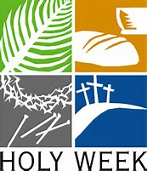
HOLY WEEK SCHEDULE
Please make plans to come to Holy Week Services, especially Easter Vigil.

EASTER VIGIL, APRIL 1st @ 8:30 PM
Please make it a priority to come to the heart and soul of our year. The core of what we believe.
Meet outside for the Service of Light.
Holy Thursday, March 29th @ 6:30 PM
“On the night before he died, He took bread….” Come!! This is THE actual night!
We need Volunteers for Feet Washing. At this service, anyone can come forward. Please, seriously, come up, especially if you haven’t stepped up before!
How we start? Everyone brings Bells and rings them!
- Consolidate your Rice Bowl change, and bring non-perishable food items.
- Transfer of the Holy Eucharist to Altar of Repose (O’Connell Hall). Plan to spend time in silent Adoration. Adoration concluding at 10:00PM with night prayer.

Good Friday, March 30th @ 2:00 PM
Most solemn time to spend together commemorating the time Jesus died on the Cross for us.

MEMORIAL GIFTS
St. Mark has recently received Memorial Gifts in memory of:
SARAH DeLUCIA
from Thomas & Lori Gasbarre; Art & Sue Beidler & Family, Jack & Joann D’Ambrisico & Family and Steve Smith & Family.
And in memory of JUDY SHERMAN
from Dennis Fapore
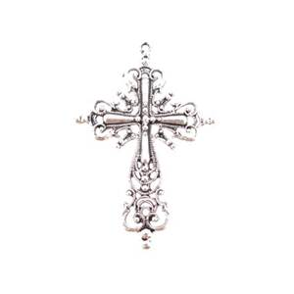

The Sanctuary Lamps burn before the
Blessed Sacraments this week
IN LOVING MEMORY OF
ARTHUR & ROSE BOGART
By Bill & Sue Bogart

March 25, 2018 ~ Palm Sunday Gospel: Mark 14:1—15:47 (The Passion of Jesus) Key Passage: ‘Father, remove this cup from me….”
Question of the week: Adult: Is there a cup you ask the Lord to remove? Youth: What part of Jesus’ crucifixion do you remember most?

