Holy Week: St. Mark Church 2019

THE HEART OF THE LITURGICAL YEAR
The Paschal Triduum: Holy Thursday, Good Friday and Easter Vigil
Easter Vigil

“The Mother of All Nights”
Saturday, April 20th @ 8:30 PM
- Baptism : Mandy Songer
- Celebrations of First Eucharist and Confirmation:
Leslee Berry and Coltin Strahl
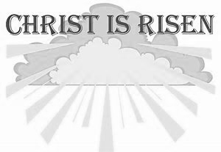
- Confirmation: Preston Gennocro
April 19th, Good Friday
Day of Fasting
- Morning Prayer at 9:00 AM in O’Connell Hall
The Passion of the Lord
- Celebration of the Lord’s Passion at
2:00 PM—Includes Veneration of The Cross and Holy Communion
- Collection for the Holy Land
April 21st, Easter Sunday
Mass at 9:00 AM
Alleluia! The Truth of the Risen Christ
is fully realized with a
Great Celebration of Joy!

April 18th, Holy Thursday Evening Mass of the Lord’s Supper 6:30 PM
- Adoration of the Blessed Sacrament follows in O’Connell Hall until 10:00 PM
Evening prayer at 10:00 PM
(Please see bulletin for all details of Holy
Thursday Mass.)

April 20th, Holy Saturday
- Morning Prayer at 9:00 AM
in church
The Easter Vigil in the
Holy Night 8:30 PM
- Meet on the front lawn for the Service of Light

PASSION {PALM} SUNDAY APRIL 14, 2019

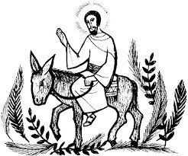

PALM SUNDAY
Jesus entered Jerusalem in triumph and left in disgrace. He entered carried by a donkey colt, hailed by the crowds with branches and hosannas. He left walking, even stumbling under the weight of the Cross, to the place of execution outside the city walls, jeered there by the bystanders. Lent is a season of contradictions, a season of successes and failures, culminating in the great paradox of the Cross, where all apparent failure yields to the ultimate triumph of life over death.
During his public ministry, Jesus spoke to the weary, the hopeless, the sick, and the grieving, a word that roused them to new purpose, the purpose of the gospel. Jesus continues to do so today, as we gather to hear the word proclaimed. But the prophet does not hide the cost. Jesus did indeed appear to be disgraced and shamed in the eyes of his short-sighted enemies, but opposition did not keep him from his appointed mission, as it must not keep us, his disciples.

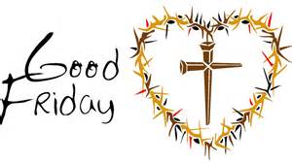
GOOD FRIDAY
ECUMENICAL SERVICE
EMPORIUM ALLIANCE CHURCH
SIZERVILLE RD.
FRIDAY, APRIL 19TH @ 12:00 PM

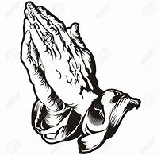
THURSDAY, APRIL 18th
‘OPEN DOOR CHURCH’ is:
ST. MARK
12:00 -1:00 PM
If you can make it, please come to pray as well as be a gracious host. We’ll be interceding the needs of our Cameron County and its people.

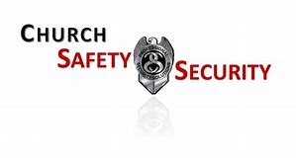
CHURCH SECURITY & INTRUDER AWARNESS TRAINING:
Wed. April 24th, 5:30 to 7:30 PM at the
EMPORIUM FIRE HALL
Co-sponsored by Cameron County Sheriff office and Emporium Police Dept. Guest speaker Chief Deputy Merle Gisey
(Venango Co. Sheriff’s Dept.)
NO COST TO ATTEND.

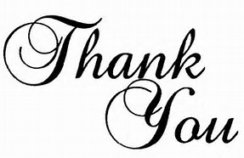
Thank you for the beautiful flowers, gifts & many cards I received for my birthday! You made my day and warmed my heart! Many blessings!

~Margie Tauses
April 14, 2019 Passion Sunday Gospel: Luke 22:14—23:56 (The passion of Jesus)
Question of the week: Adult: When have you felt that you betrayed the confidence of another, as Peter did when he denied Jesus? Youth: When have you let someone down who trusted you? How did you feel?

EASTER TRIDUUM
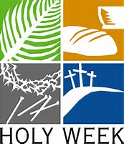
Over “The Three Days” we enter into the entirety of the Paschal Mystery. It is one unified event. Because of this, try not to choose your favorite. By not going to all three, you miss the unified movement for the Lord’s Supper, to the cross, to the empty tomb, to the Risen Christ. (Please refer to the cover sheet for the schedule and important information.)
Holy Thursday, April 18th @ 6:30 PM
“On the night before he died, He took bread….” Come!! This is THE actual night!
We need Volunteers for Feet Washing. At this service, anyone can come forward. Please, seriously, come up, especially if you haven’t stepped up before!
How we start? Everyone brings Bells and rings them!
- Consolidate your Rice Bowl change, and bring non-perishable food items.
- Transfer of the Holy Eucharist to
Altar of Repose (Everyone processes to O’Connell Hall). Plan to spend time in silent Adoration. Adoration concluding at 10:00PM with night prayer.

Good Friday, APRIL 19th @ 2:00 PM
Most solemn time to spend together commemorating the time Jesus died on the Cross for us.

EASTER VIGIL, APRIL 20th @ 8:30 PM
Please make it a priority to come to the heart and soul of our year. The core of what we believe. Meet outside for the Service of Light. BRING YOUR BELLS FOR THE GLORIA! Everyone receives a candle. Please plan to attend the reception in honor of
MANDY SONGER our Elect
and Full Members, COLTIN STRAHL,
LESLEE BERRY and PRESTON GENNOCRO!

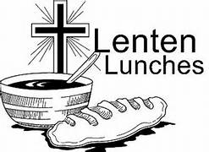
LENTEN LUNCHES
St. Mark Lenten Lunches were a great success! Thanks to all who worked so hard and contributed in any way.
(We will not have luncheon this week due to Holy Week.

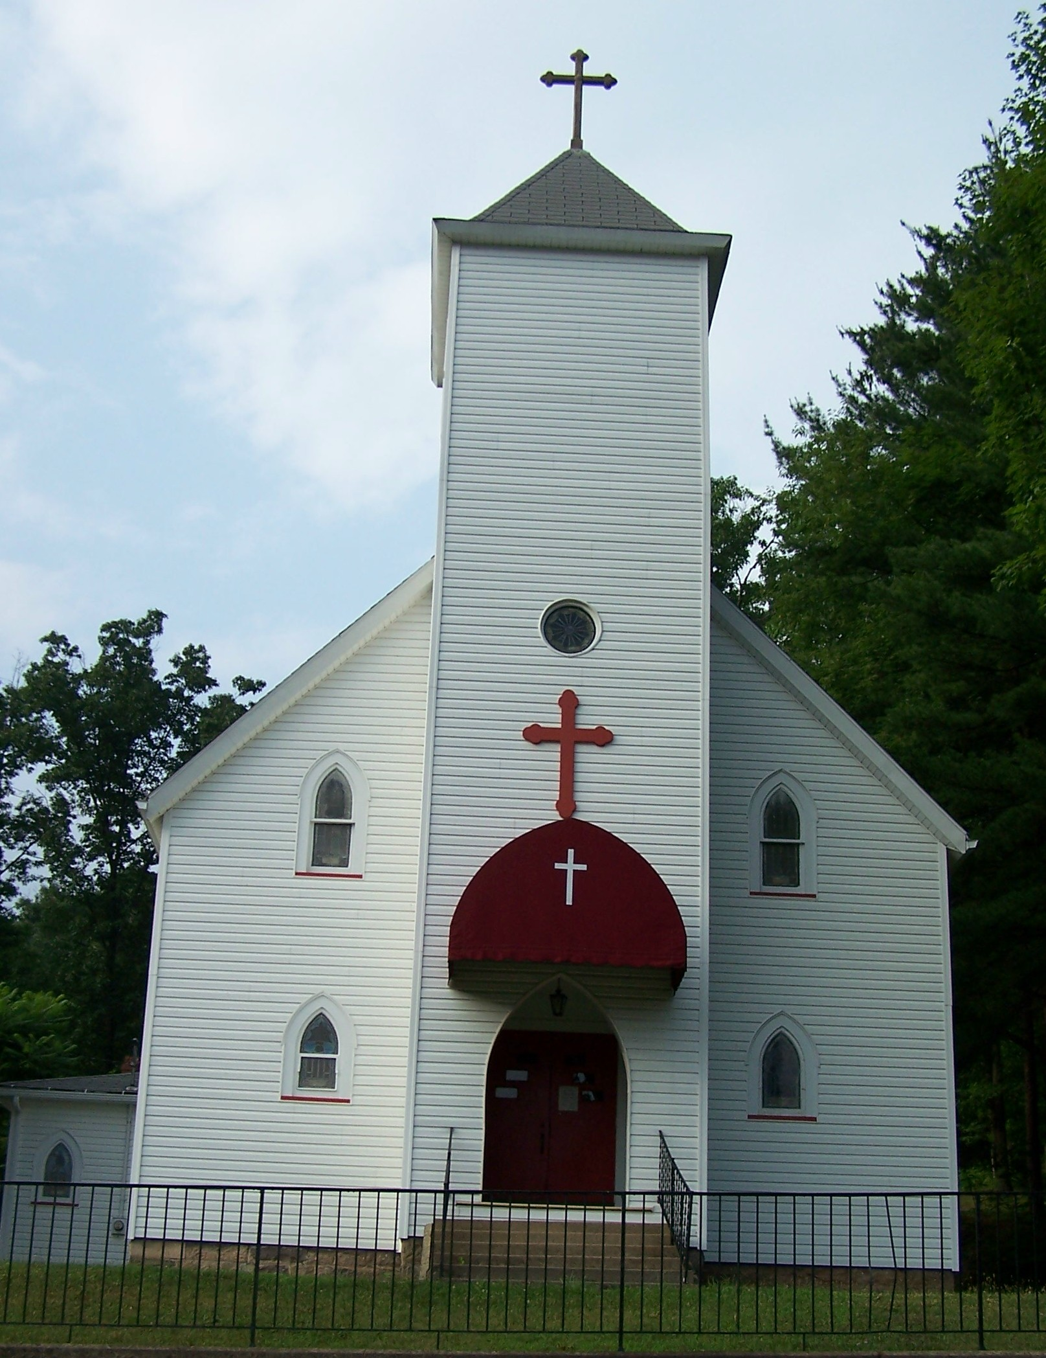
ST. JAMES, DRIFTWOOD
St. James Church, Driftwood, will re-open for the spring, summer & fall seasons
SATURDAY, APRIL 27th
Mass time is at 4:30 PM
ALL ARE WELCOME!

EXTRAORDINARY MINISTERS: LECTORS:
Holy Thursday ~ 6:30 PM Holy Thursday ~ 6:30 PM
C. Copp, P. English, J. Grimone, P. Housler, J. Laughlin Pat Rodgers, Joe DeLucia
Good Friday ~ 2:00 PM Good Friday ~ 2:00 PM
Ralph Grovanz & Melissa Stuart
Easter Vigil, Holy Saturday ~ 8:30 PM Easter Vigil, Holy Saturday ~ 8:30 PM
V. Fragale, J. Laughlin, L. Summerson, C. Schager, F. Pizzella Dave Malize, Jane Kamats & Sarah Abriatis
Easter Sunday ~ 9:00 AM Easter Sunday ~ 9:00 AM
P. DeLucia, F. Manginell, P. Rodgers, S. & L. Zoschg John English

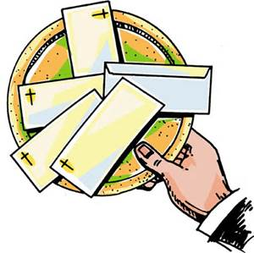
OFFERTORY COLLECTION
APRIL 6-7 2019
St. Mark: $5,211.00
St. James: $423.00 Thank you for returning some of God’s gifts to you to His Church.
MASS ATTENDANCE
MARCH 30-31 2019
St. Mark: 5:00 PM – 124
9:00 AM – 134

ALTAR SERVERS:
Holy Thursday ~ 6:30 PM Easter Vigil, Holy Saturday ~ 8:30 PM
Jonathan & Samantha Good, Sophia Fragale, Noah & Zach Abriatis, Molly & Maggie
Caleb Rieder & Trisha Kossman Abriatis & Delany Rowan
Good Friday ~ 2:00 PM Easter Sunday ~ 9:00 AM
Toni Dresser & Andy DeLucia Andy & Emily Richnafsky
SCHEDULE OF EVENTS:
Sunday (14th) PALM SUNDAY
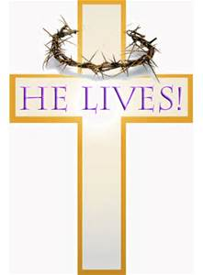
10:15-11:30 – Religious Ed. Classes Grades 6-11
Wednesday (17th) No Religious Ed. Class Grades 1-5 ~ Easter Break
4:30 PM – Stations of the Cross
No Adoration of Blessed Sacrament or Holy Hour
Sacrament of Reconciliation by Appointment Only
Thursday (18th) 6:30 PM –HOLY THURSDAY SERVICE
Friday (19th) 9:00 AM– Morning Prayer
2:00 PM – CELEBRATION OF THE LORD’S PASSION
Saturday (20th) 9:00 AM – Morning Prayer
8:30 PM – EASTER VIGIL
Sunday (21st) 9:00 AM – EASTER SUNDAY MASS
No Religious Ed. Classes Grades 6-11 ~ Easter Break

MASS INTENTIONS:
MONDAY, APRIL 15
8:10 a.m. RICHARD W. HICKOFF
(Joan Klinestiver)
(Is 42:1-7; Jn 12:1-11)
TUESDAY, APRIL 16
8:10 a.m. COMMUNION SERVICE
(Is 49:1-6; Jn 13:21-33. 36-38)

WEDNESDAY, APRIL 17
8:10 a.m. DAVID KARKOSKA
(Mr. & Mrs. Leon Marlow)
(Is 50:4-9a; Mt 26:14-25)

HOLY THURSDAY, APRIL 18
6:30 p.m. JAMES COPPERSMITH (ANNIV.)
(Vince & Molly Fragale)
(Ex 12:1-8, 11-14; 1 Cor 11:23-26; Jn 13:1-15)
GOOD FRIDAY, APRIL 19
9.00 a.m. MORNING PRAYER
2:00 p.m. THE LORD’S PASSION
(Is 52: 13-53:12; Heb 4:14-16. 5:7-9; Jn 18:1-19)
HOLY SATURDAY, APRIL 20
9:00 a.m. MORNING PRAYER
8:30 p.m. EASTER VIGIL
JOSEPH ROSETTE
(Darlene & Pat Vogt)
SUNDAY, APRIL 21
9:00 a.m. PEOPLE OF THE PARISHES
(Acts 10:34a, 37-43; Col 3:1-4; Lk 24:1-12)

