ST. MARK CHURCH EMPORIUM, PENNSYLVANIA
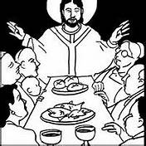
THIRD SUNDAY OF EASTER The resurrection is not just about Jesus rising from the dead; it is about the renewal of all of creation. “Let all the earth cry out to God with joy,” for Christ is risen, and with him all creation. The resurrection of Jesus is also about our own resurrection, which we anticipate with hope. We pray that our Easter “joy will come to perfection in heaven.” But we know that there is a life to be lived, a life of struggle for the sake of the Gospel. By persevering in the effort to bring good news to the earth and all its inhabitants, we will one day join in with “the voices of every creature in heaven and on earth and under the earth and in the sea” in a song of praise and honor “To the One seated on the throne, and to the Lamb.”

Thanks to all who helped in any way to make our Holy Week celebration so very meaningful. Our Liturgy Committee, both Choirs, Bernie Oswald, RCIA team, Servers, Lectors, cleaning crew, Parish Staff & everyone else. Such a wonderful way to call to mind the saving event of Passion, Death, and Resurrection of our Lord! Thanks also to all who sent cards, prayers, food & goodies to the rectory. I enjoyed it all!
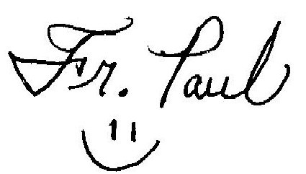
God Bless you All!

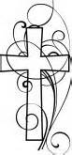
IN YOUR CHARITY,
Please pray for the souls of
TODD PARISI, brother of Mrs. Ann Losey
and REGINA SMITH, who passed away recently. May their souls and the souls of all the faithful departed rest in peace.
Amen

DIOCESAN CHILD ABUSE POLICY UPDATE
You can find the entire child abuse policy, the statements from our news conference and additional information at
www.ErieRCD.org/policyupdate
To report abuse to the independent investigators retained by the Diocese of Erie, email
ErieRCD@KLGates or call ChildLine @
800-932-0313 24/7 or call the Diocese directly @ 814-451-1543. The Diocesan Victim Assistance Coordinator is
Dr. Robert Nelsen, 814-451-1521.

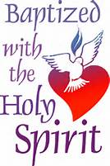
Today we welcome, through the saving waters of Baptism:
ELLA MAE WISSNER
Daughter of Trent & Malarie Campbell Wissner
&
CAMBREE GRACE STUART, HARPER ANN STUART and TANNER MARSHALL REID, children of
Jody & Audra Reigel Reid & Justin Stuart.
May the Dear Lord bless & keep you all!

April 15, 2018 ~ Third Sunday of Easter Gospel: Luke 24:35-48 (Jesus appears to the Eleven)
Question of the week: Adult: What question about Jesus still arise in the midst of your faith?
Youth: What question would you like to ask someone about Jesus’ appearance to the Apostles?

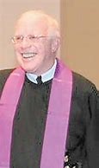
ST. MARK/ST. JAMES PARISH MISSION
Next Sunday the Mission begins, being conducted by Redemptorist, Fr. Eugene O’Reilly. Mark your calendar & come! Fr. O’Reilly will join us for the Saturday evening Masses & will preach at the Sunday Mass to share with you the benefits of attending a Mission.
Fr. O’Reilly will also be at the morning Masses that week. The evening services are scheduled to last appx. one hour. He’ll have fun and inspiring talks Sunday through Wednesday night. Bring your friends & family! Fr. O’Reilly was born in Monoghan, Ireland. He’s well educated, but captivating and down to earth. At the mission, he will sing songs that he has written. He is known for his teaching on joy & compassion, his touching stories and his humor.
Don’t miss it!
Please joining us for our Parish Mission,
April 22nd, 23rd, 24th & 25th.

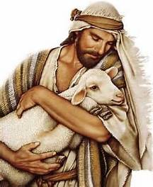
The Good Shepherd
Collection
The annual Good Shepherd Collection will be taken up in all parishes in the Diocese of Erie next weekend, April 21-22. This ‘second’ collection allows each of us to show our gratitude and support for those priests who have cared for us and our spiritual needs and faithfully serviced our parishes.

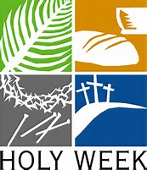
ST. MARK HOLY WEEK
WHO’S WHO
We’re proud and grateful to all who helped, serve and minister to us at
St. Mark during the Holy Week Services. Our gratitude goes out to the
following participants:
Holy Thursday—Mass of the Lord’s Supper
Presentation of the Holy Oils:
Oil of the Sick: Cindy Cook & Family
Oil of the Catechumens: Jody & Audra Reid & Children
Holy Chrism Oil: Maryann Cashdollar, Kay Mix & Elyse Spehalski
Lectors: Pat Rodgers & Vicky Songer
Announcer: Ted Walters
Washing of the Feet: Presiding: Rev. Paul S. Siebert
Mike & Kate Fragale, Margaret Grimone, Jane Kamats, Zack & Abbi Kane & Children, Loretta Montgomery, Jody & Audra Reid & Children, Diane Schuckers, Dave & Lynn Summerson
Dressing the Altar:
Annette Campbell, Joe Fragale, Sophia Fragale, Taylor Fragale, Vince & Molly Fragale
Gift Bearers: Dave and Lynn Summerson

THIRD SUNDAY of EASTER __ APRIL 15, 2018

HAPPY Belated BIRTHDAY
MRS. MARY SIEBERT
Friday, April 13th!
Cards can be sent to:
C/O Guy & Mary Felt Manor, 110 E. 4th St.
Emporium, Pa 15834.
She’d love to hear from you!

BIRTHDAY BREAKFAST
Join us for April Birthday Breakfast,
Friday, April 20th following morning mass (8:45 AM) in O’Connell Hall. All are welcome!

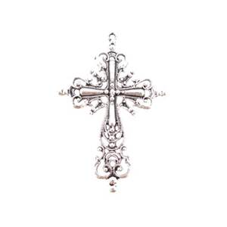
~~~~~~~~~~~~~~~~~~~~~~~~~~~~~~~~~~~~~~~~~
The Sanctuary Lamps burn before the
Blessed Sacraments this week
IN LOVING MEMORY OF,
BARNEY HORNUNG
By Ron & Carol Dankesreiter
~~~~~~~~~~~~~~~~~~~~~~~~~~~~~~~~~~~~~~~~~

ST. MARK EXTRAORDINARY MINISTERS:
WEEKEND OF APRIL 21-22
6:30 PM – M. & J. Laughlin, L. Summerson, D. & C. Malize
9:00 AM – P. DeLucia, P. Rodgers, K. Strycula, R. Woods,
C. Dankesreiter

ST. JAMES EXTRAORDINARY MINISTERS:
WEEKEND OF APRIL 21
4:30 PM – Dolly Gennocro & Marlene Farren
LECTOR: Laura Zoschg

SCHEDULE OF EVENTS
Sunday (15th) 10:15-11:30 – Religious Ed. Classes Grades 6-11
Wednesday (18th) 3:30-5:00 PM – Religious Ed. Class Grades 1-5
6:00 PM – Adoration of Blessed Sacrament ~ Intention ~ Increase in 6:00 PM – Confession Vocations to the Priesthood
7:00 PM – Benediction & Religious Life
Thursday (19th) 6:30 PM –Recitation of Rosary
Friday (20th) 8:45 AM – Birthday Breakfast ~ O’Connell Hall
Saturday (21st) 2:30 PM – Confession
Sunday (22nd) 10:15-11:30 – Religious Ed. Classes Grades 6-11

Download ST. MARK
at MyParish App on your iPhone or Android SmartPhone. It’s easy to do
& has lots of great features.

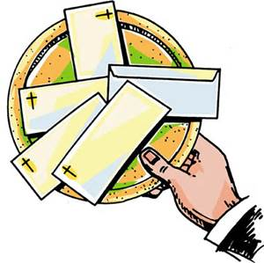
OFFERTORY COLLECTIONS
April 7-8, 2018
St. James: $565.00
St. Mark: $4.909.00
MASS ATTENDANCE
April 7-8, 2018
St. Mark: 5:00 PM – 133
9:00 AM – 122
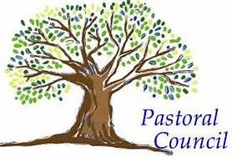
PASTORAL COUNCIL
MEETING
MONDAY, APRIL 16TH @
4:30 PM

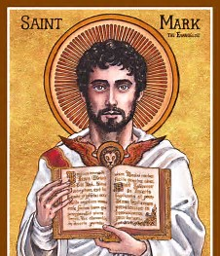
ST. MARK FAMILY BRUNCH
SUNDAY, APRIL 29
Following First Holy Communion Mass.
Everyone is invited and encouraged to join us for our annual brunch. There’s a sign-up sheet in the back of the church to give us an indication as to how many are planning on attending.
Please come celebrate First Holy Communion, the Feast of St. Mark (4/25/18) & wish Fr. Paul a Happy ‘Ordination’ Anniversary!

WEEKEND OF APRIL 21-22
LECTORS:
6:30 PM – Dave Summerson
9:00 AM – Sarah Abriatis
ALTAR SERVERS:
6:30 PM – Maggie & Sarah Abriatis
9:00 AM – Isaac Grovanz & Delaney Rowan
Children’s Liturgy:
Kristen Summerson

Like us on Facebook:
St. Mark Catholic Church Emporium
or visit our website:
www.stmarkemporium.org

