

FIRST ANNUAL ST. JOSEPH CHURCH GOLF OUTING AT THE

BAVARIAN HILLS GOLF COURSE

SUNDAY, SEPTEMBER 19, 2021

SHOTGUN START 1:00 PM

FOUR-PERSON SCRAMBLE

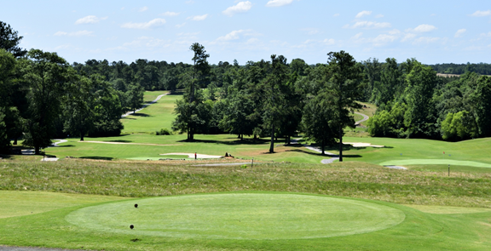

FIRST “HOLE IN ONE” WILL WIN $10,000

CLOSEST TO PIN: NEW PUTTER

LONGEST DRIVE: NEW DRIVER

THESE 3 PRIZES DONATED BY:

ST. MARY’S INSURANCE AGENCY



PRICE: $80/PERSON -- $65/BAVARIAN GOLF MEMBER

INCLUDES:

LUNCH, CARTS, GREEN FEES, DINNER, PRIZES

& REFRESHMENTS ON THE COURSE

TO SIGN UP CONTACT JOHN BAUER AT THE BAVARIAN HILLS GOLF COURSE @ (814)834-3602

OR

FATHER MARK MASTRIAN AT ST. JOSEPH CHURCH

@ 814-787-4151 #4