Weekend of March 24/25 Palm Sunday of the Passion of the Lord
Mon (SM) March 26 8:00 am Bill Deegan by Kitty & Paul Johnson
Tue (ABVM) March 27 ----- No Mass
Wed (SM) March 28 7:00 pm Liz Deegan by Mary Delaney

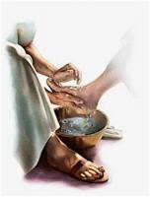

Thur – Holy Thursday - Evening Mass of the Lords Supper
(ABVM) March 29 7:00 pm Evelyn Simbeck by Cheryl, Ron & Maddie Hannah
Fri – Good Friday – Passion of the Lord
(SM) March 30 1:00 pm
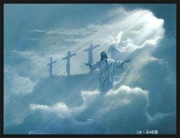
Sat – Holy Saturday – Easter Vigil
(ABVM) March 31 8:30 pm Joseph Canton by Fred & Wilma
Sunday - Easter Sunday
(ABVM) April 1 8:30 am All Parishioners of Both Parishes
Sun (SM) 11:00 am Monsignor John Mignot by the Zaffuto Family
Ministers Schedule:
Holy Thursday – March 29 – 7:00 p.m. Holy Saturday – March 31 – 8:30 p.m.
Servers: Enseki Sisters W & E Bacha
Lector: Diane Varacallo Lectors: Reading 1 – F Rosana
Euch Min: W Torretti J Satterlee 2 – J Satterlee
3 – K Witherite
Epistle: J Gruda
Euch Min: E Fike, J Pisarcik
Sunday – April 1 – Easter Sunday – 8:30 a.m.
Server: A Little
Lector: P Roman Euch Min: D & T Laukitis Samaritan Outreach: A Bonavita
Sacrificial Giving: $1905.00
Holy Hour – The Holy Hour for Assumption Church will take place this Tuesday, March 27th – 6:30 p.m.
New Parish website address: www.stmarysassumption.com Check it out today! We will continue to develop it to make it a great website! .
Marianna Hoagie Sale – Anyone who would like to still order a hoagie still may do so by calling Josephine (371-0725) until Sunday evening!
Lenten Penance Service - The last Penance Service is this Sunday, March 25th – 3 pm at St. Catherine, DuBois.
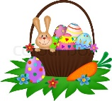
Divine Mercy Sunday devotions will be held on Sunday, April 8th at Assumption Church at 3 p.m. Adoration of the Blessed Sacrament will take place from 2 p.m. and during the service, ending with Benediction. The service will include a Liturgy of the Word, a brief homily, recitation of the Divine Mercy of Chaplet, and a veneration of the Divine Mercy Image.
Blessing of Baskets will take place at Assumption parish on Saturday, March 31st at 12 noon.
Coffee, Donuts & Treat Bags for the Children will take place immediately following the 8:30 am Easter Sunday Mass at Assumption Parish. Everyone Welcome!!
The Catholic Daughters of the Americas, Court #890 will meet Monday, March 26th at 6:30 pm at St. Mary’s Church in Reynoldsville, in the social hall. Please bring an item for our “White Elephant” raffle that night.
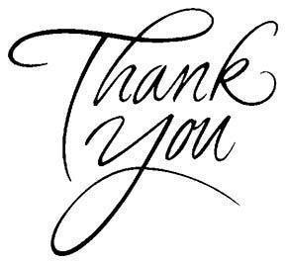
A hearfelt thanks is in order for all who worked so hard to put on our annual Lenten Fish dinners. The dinners are a great joy and much fun for all or our partons, even though they are a cause of significantly sore muscles and some frazzled nerves for our workers!! Of course, they are a significant source of income for Assumption Parish as well, and we will be sharing our report with you in coming weeks. Again, my blessing to all those who worked so hard to put on these dinner. Fr. Bill Barron
Blood Drive will take place at Sykesville Methodist Church on March 29th from 1:00 – 5:30 p.m.
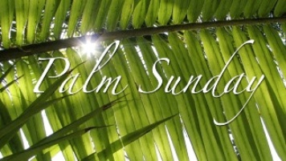

DuBois Central Catholic Drawing – DCC $10,000 Grand Prize Drawing will be held on April 21st 2018. Cost: $100 per ticket includes admission for 2 to the Drawing Party. Party starts at 7:00 pm at DuBois Central Catholic. Need not be present to win. Only 235 tickets sold so get yours today! 1st Prize - $10,000 – 2nd $1,000 – 3rd $500 – 4th $200 & 5th - $100. Call Fred Deemer (541-7037).
DuBois Central Catholic is the “place to be” on Palm Sunday, March 25th. The Junior Class of Central and their parents are hosting the annual PALM SUNDAY SPAGHETTI Dinner in the cafeteria from 11 am to 2 pm. Adults: $10.00 and children under 12 - $5.00. It’s authentic Italian…both delicious and plentiful! Take-outs available. All proceeds benefit the Junior-Senior Prom. In addition, DCC’s 7th Grade Science Fair will be on exhibit in the school’s gym and the Spring Book Fair will be welcoming visitors in the Elementary Library. You’ll find something for everyone at DCC on Palm Sunday! Make it a Family Event!!
Parish Councils – In 2017, the Diocese of Erie combined St. Mary’s and Assumption Parish Councils. We have some openings on the council that need to be filled by election of the parishioners. The election will take place on the weekend of April 21/22nd, using the collection basket. If you will be away that weekend, and would like to request an absentee ballot, call your parish office. We will be electing 1 member from St. Mary’s Parish, and 2 members from Assumption Parish. St. Mary’s parishioners will vote for the St. Mary’s representative, and Assumption Parishioners will vote for the Assumption representatives. All confirmed members of the parishes are eligible for election. To be nominated for the ballot, please obtain the signatures of parishioners who are not your immediate family members, and mail the signatures to Moose Rosana, Parish Council President, by Friday, April 6th. 116 Barletta Rd. Reynoldsville, PA 15851. Thanks, Father Bill

