Weekend of March 10/11 Fourth Sunday of Lent
Mon (SM) March 12 8:00 am Louie Fusco by Gary, Lynn & Family
Tue (ABVM) March 13 9:00 am Sister Michele Leehan by Sisters of Mercy
Wed (SM) March 14 8:00 am Stanley Verona by Barry & Luba
Thu (ABVM) March 15 ---- No Mass
Thu (SM) March 15 7:00 pm Stations of the Cross
Fri (SM) March 16 8:00 am Doug Smelko by Wednesday’s Spiritual Sharing Group
Saturday Vigil Mass
Sat (ABVM) March 17 4:30 pm Sara Witherite by Mike & Rita Krishart
Sun (ABVM) March 18 8:30 am All Parishioners of Both Parishes
(SM) 11:00am Louis & Wayne Borelle by Marc, Erin, Sue & Eric
Ministers Schedule
Saturday –March 17 – 4:30 p.m. Sunday –March 18 – 8:30 a.m.
Servers: C Lanzoni, A Rake A Little
Lectors: J Satterlee S Jovenitti
Euch Min: B Stover A Bonavita
D Slawson D Laukitis

Samaritan Outreach: S Lang

Sacrificial Giving: $2642.00
Prayer Chain: The prayer chain effectively bring spiritual help to those in need. For prayer requests, please call Marlene Boboige (894-5659) or Sheri Lang (583-7792). These requests should be renewed monthly if needed.

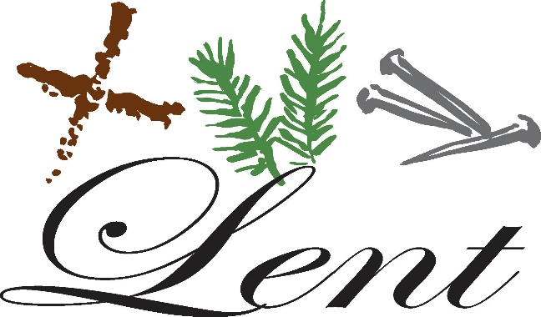
Holy Hour – The Holy Hour for Assumption Church will take place this Tuesday, March 13th at 6:30 p.m.
New Parish website address: www.stmarysassumption.com Check it out today! We will continue to develop it to make it a great website! .
Flower Memorials – In your packet of contiibutuion envelopes for March you will find an envelope designated for Easter Flowers. Please use this envelope for your Easter Remembrances of Deceased Loved ones by writing their names on the envelope and dropping it in the collection basket at any weekend Mass now through March 24/25th. Names of Memorialized Loved Ones will be published in the Parish bulletin on Easter Sunday, April 1st.
Marianna Hoagie Sale – The Rosary Society is now doing their annual hoagie sale starting this weekend, March 10/11th. If you are able to please support this annual sale to our Society. Their profit always goes back in to the church for maintenace or other church projects. Your support is much appreciated! You can place an order from now until Friday, March 23rd. Place your order in the collection basket if you wish to do so. The hoagies sheet is being used as a bulletin insert this weekend. Delivery date will be April 4th. Thank you again for your support to the Society and this fundraiser! All orders need to be picked up at the Social Hall. If you need to make different arrangements, please call Josephine (371-0725).
Central Catholic Elementary is holding Kindergarten registration for the 2018-2019 school year on Thursday, March 15th. The student must be five years of age by July 1st. Please call the school (371-2570) for information and to make an appointment.
Central Catholic Elementary is accepting applications for preschool for the 2018-2019 school year. Tuition assistance applictions are available. Please call the school (371-2570) for information.
Parish Seder Meal – Our Parish Seder Meal will take place on Wednesday, March 28th in the church Social Hall. The Seder Meal will begin at 6:00 p.m. in the Social Hall. A sign-up sheet is now posted at the entrance of the church and also by the door entrance at the ramp door next weekend. The parish will provide meat, rolls and beverages. Please bring a covered dish for this Religious Event. In the Christian Tradition of the Passover Seder is believed to be when Jesus instituted the Eucharist.
Lenten Penance Services – 2018 are as follows: Sunday, March 18th SS.Cosmas & Damian, Punxsuatwney, 3 pm
Monday, March 19th St. Mary’s Parish, Reynoldsville, 7 pm Tuesday, March 20th Immaculate Conception, Brookville, 7 pm Wednesday, March 21st St. Tobias, Brockway, 7 pm Sunday, March 25th St. Catherine, DuBois, 3 pm.
Spaghetti Dinner will be held at St. Bernard Church, Falls Creek next Sunday, March 18th from 11 am until 1:30 pm or until sold out! Take-outs are available; please bring your own container.
Scripture Sharing: The Rural House of Mercy’s monthly Scripture Sharing will be on Wednesday, March 14th at 10:15 at St. Mary’s in Reynoldsville. This month’s scripture reading is Mark 1: 14-15 and 2 Timothy 2: 8. All are welcome.

ANNUAL LENTEN FISH DINNERS
A.B.V.M. 27th Annual Lenten Fish Dinners: Dates: March 9, 16, & 23rd
Time: 4:00 – 6:30 p.m. Where: Assumption Social Hall
Menu: Breaded, New Baked Fish – Potato Crusted Cod with chives and cheddar cheese seasoning
6 oz. piece, or Shrimp. Meals include: Baked or French Fried Potato, Homemade Macaroni & Cheese or Haluski, Stewed Tomatoes, Coleslaw, Rolls, Butter, Dessert & Beverage.
Cost: Adults: $9.00; Children 12 & Under $4.00. Take-outs available. 50/50 Drawing each week.
Handicapped Accessible, Ample Parking. Come and join us for conviviality and a chance to win the 50/50 drawing!!!!

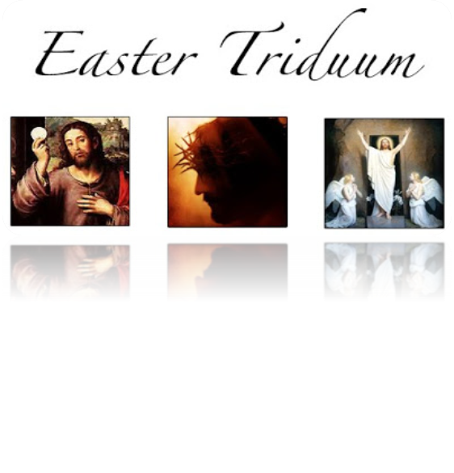
Seder Meal, Wednesday, March 28th 6:00 p.m. A.B.V.M. Social Hall
Holy Thursday March 29th – 7:00 p.m. A.B.V.M. Church
Adoration until 10:00 p.m. at Assumption Church Only!
Good Friday, March 30th – 1:00 p.m. St. Mary’s Church
Holy Saturday March 31st – Easter Vigil Mass –Assumption Parish - 8:30 p.m.
Easter Sunday
Sunday, April 1st – 8:30 a.m. A.B.V.M.
11:00 a.m. St. Mary’s Parish
Holy Saturday, Blessing of Easter Baskets, A.B.V.M. Parish 12:00 Noon
Coffee & Donuts will be served following the Easter Sunday Mass!! There will also be Treat Bags for the children! All are Welcome!!
DuBois Central Catholic Drawing – DCC $10,000 Grand Prize Drawing will be held on April 21st 2018. Cost: $100 per ticket includes admission for 2 to the Drawing Party. Party starts at 7:00 pm at DuBois Central Catholic. Need not be present to win. Only 235 tickets sold so get yours today! 1st Prize - $10,000 – 2nd $1,000 – 3rd $500 – 4th $200 & 5th - $100. Call Fred Deemer (541-7037).
DuBois Central Catholic is the “place to be” on Palm Sunday, March 25th. The Junior Class of Central and their parents are hosting the annual PALM SUNDAY SPAGHETTI Dinner in the cafeteria from 11 am to 2 pm. Adults: $10.00 and children under 12 - $5.00. It’s authentic Italian…both delicious and plentiful! Take-outs available. All proceeds benefit the Junior-Senior Prom. In addition, DCC’s 7th Grade Science Fair will be on exhibit in the school’s gym and the Spring Book Fair will be welcoming visitors in the Elementary Library. You’ll find something for everyone at DCC on Palm Sunday! Make it a Family Event!!
Faith Formation Classes in March – March 17th Reconciliation at 10:00 am at St. Catherine’s Church. March 20th – The second parent meeting for First Communion at McGivney Hall, 6:30 – 7:30 pm. No Religious Ed Classes on April 1st.
Evening of Prayer and Music will be held on Sunday, March 18th. It will include a homily, Scripture reading, and prayers for healing with Fr. Mark Mastrian. It will be held at St. Bernard’s Church, Falls Creek. The time will be 6:00 pm. The music ministry will be Shalom, for more information, contact Judy Smart (637-5930) or Rich Kenawell (771-7932).

